**Interview test exercise**

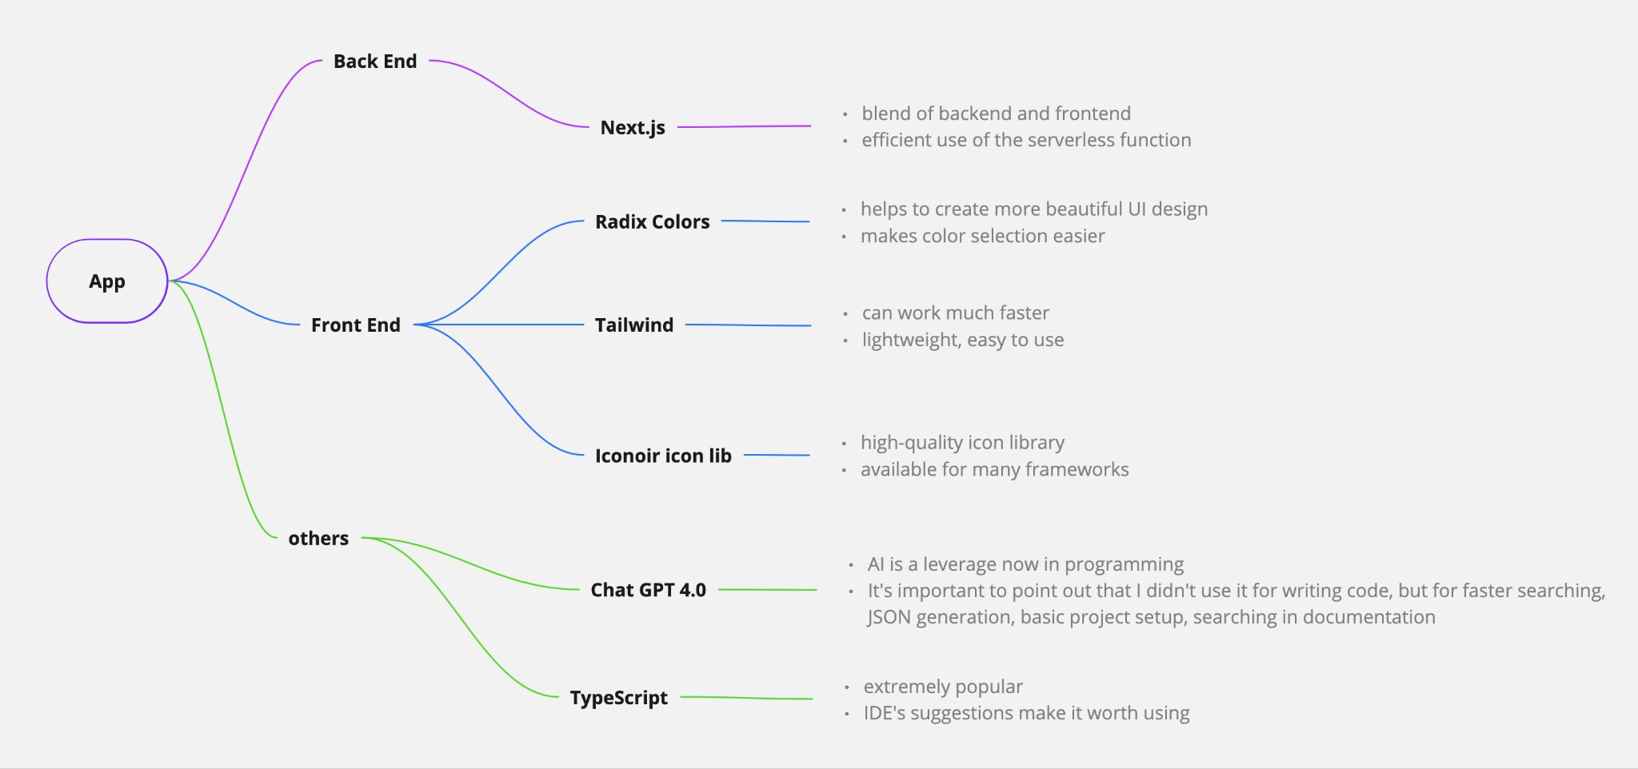

**01 Tech stack**

My mentor emphasized the importance of focusing on programming concepts, algorithms, and models over frameworks or libraries. Although I'm familiar with the MERN stack and have used NEXT.js once, I can produce more professional, cleaner and more functional code in the MERN environment. Despite my familiarity with MERN, I decided to demonstrate my ability to write clean code in NEXT.js at the job interview to demonstrate versatility and competence beyond my primary framework preferences.

**02 Validation**

If users leave a mandatory field blank or type a string format into a numeric input, an error message is displayed prompting them to correct the error before proceeding. The validation process acts as a checkpoint to ensure that all input matches the expected format before users can proceed.

**03 Dynamic Rendering of Employee Data**

The CompanyForm component generates a form for entering company data and dynamically generates employee forms based on the number of employees. The data is stored locally and can be sent to a backend service. Users can easily navigate between company and employee data using the dashboard provided by the application.

**04 Consequences if the user changes the number of employees**

If users want to change the number of an employee in the company, a warning message will be displayed to warn them that the employee's details will be deleted.

**05 Handle PDF files**

When employees upload their CVs, the system stores the URL in localStorage.